https://www.researchgate.net/profile/Erkam_Gueresen/publication/220219343_Using_artificial_neural_network_models_in_stock_market_index_prediction/links/5bbcc6a4299bf1049b785346/Using-artificial-neural-network-models-in-stock-market-index-prediction.pdf

https://sceweb.uhcl.edu/boetticher/ML_DataMining/Kimoto.pdf
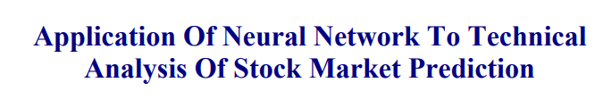

https://github.com/rosdyana/Going-Deeper-with-Convolutional-Neural-Network-for-Stock-Market-Prediction
Going Deeper with Convolutional Neural Network for Stock Market Prediction
Summary：
Data Collection
Using Yahoo! Finance for time series data source
50 Taiwan Companies from 0050.TW index.
Top 10 Indonesia Stock exchange companies.
Methodology
Using candlestick chart for input model
DeepCNN
ResNet 50
VGG16
VGG19
Randomforest
KNN

